Zoom Car booking system:
SR | User Requirement | GPT result | Our System Result
 | The system displays the log-in page. | 5 The system shall display the log-in page upon user request. | 1. The system shall be able to display the login page.
 | The customer enters his login Id with password. | 6 The system shall provide users with the ability to enter a login ID. | 2. The system shall provide customer with the ability to enter his login i d with password.
 | The customer clicks on the confirm button. | 8 The system shall provide users with the ability to click a confirm button to submit login credentials. | 3. The system shall provide customer with the ability to click on the confirm button.
 | The system checks that all of the required information was entered. | 9 The system shall check that both login ID and password fields are filled before processing login. | 4. The system shall be able to check that all of the required information entered.
 | If the entered information is wrong then system asks customer to reenter the details. | 13 If the entered login information is incorrect, then the system shall prompt the user to re-enter the details. | 5. If the entered information is wrong then the system shall be able to ask customer to reenter details.
 | The system validates the entered information. | 12 The system shall validate the entered login ID and password against the stored credentials in the database. | 6. The system shall be able to validate the entered information.
 | The Admin clicks the log-in button on the Home Page. | Missing | 7. The system shall provide admin with the ability to click the login button on the home page.
 | The system displays the log-in page. | Missing | 8. The system shall be able to display the login page.
 | The Admin enters his login Id with password. | Missing | 9. The system shall provide admin with the ability to enter his login i d with password.
 | The admin clicks on the confirm button. | Missing | 10. The system shall provide admin with the ability to click on the confirm button.
 | The system checks that all of the required information was entered. | Missing | 11. The system shall be able to check that all of the required information entered.
 | If the entered information is wrong then system asks Admin to reenter the details. | Missing | 12. If the entered information is wrong then the system shall be able to ask admin to reenter details.
 | The system validates the entered information against the tables stored in the database. | 12 The system shall validate the entered login ID and password against the stored credentials in the database. | 13. The system shall be able to validate the entered information against the tables stored in the database.
 | The customer already has navigated to the main options screen. | Missing | 14. The system shall provide customer with the ability to already navigate to the main options screen.
 | The customer enters the details of source station, destination station to search cars on that route. | 16 The system shall provide customers with the ability to enter the source station. | 15. The system shall provide customer with the ability to enter the details of source station , destination station to search cars on that route.
 | The customer also enters the type of car- hatch back, sedan etc he wants to book. | 18 The system shall provide customers with the ability to select the type of car (e.g., hatchback, sedan). | 16. The system shall provide sedan with the ability to also enter the type of car hatch back , etc car wants to book.
 | Customer enters all the information- name, age, number of passengers, source station, destination station. | 19 The system shall provide customers with the ability to enter their name. | 17. The system shall provide customer with the ability to enter all the information name , age , number of passengers , source station , destination station.
 | The customer can use help facility to know how to fill the information, HelpFacility usecase is carried out. | 22 The system shall provide customers with the ability to use the help facility at any point during data entry. | 18. The system shall provide customer with the ability to use help facility to know how to fill the information , helpfacility usecase carried out.
 | He clicks the "Search" button. | 24 The system shall provide customers with the ability to click the "Search" button to search for cars. | 19. The system shall be able to clicks search button.
 | If all the required information is not entered by the customer then the system highlights the blank fields to be entered. | 26 If any required information for searching cars is missing, then the system shall highlight the blank fields. | 20. If all the required information is not entered by the customer then the system shall be able to highlight blank fields to entered.
 | After searching, the System displays a list of all the available cars that matches the customer’s input, each car in the list has an associated price. | 27 The system shall display a list of available cars that match the customer’s search criteria. | 21. The system shall be able to display a list of all the available cars that matches the customers input , each in the list has an associated price.
 | Customer must have searched for the required car. | 29 The system shall provide customers with the ability to select a car from the search results. | 22. The system shall provide customer with the ability to search for the required car.
 | System displays a screen showing the details of the booked car. | 30 The system shall display the details of the selected car after selection. | 23. The system shall be able to display a screen showing the details of the booked car.
 | The customer verifies the details. | 31 The system shall provide customers with the ability to verify the details of the booked car. | 24. The system shall provide customer with the ability to verify the details.
 | System displays a screen with input fields for: a card number, cardholder name, card expiration date. | 33 The system shall display a screen with input fields for card number, cardholder name, and card expiration date after booking confirmation. | 25. The system shall be able to clicksThe system shall be able to display a screen with input fields for a card number , cardholder name , card expiration date.
 | Customer enters the details for the card number, the cardholder name , the card expiration date. | 34 The system shall provide customers with the ability to enter a card number. | 26. The system shall provide customer with the ability to enter the details for the card number , the cardholder name , the card expiration date.
 | If customer is stuck in the process then he can use help facility to know how to fill the information, HelpFacility usecase is carried out. | 43 The system shall provide customers with the ability to use the help facility during the payment process. | 27. The system shall be able to clicksIf customer is stuck in the process then the system shall be able to use he help facility to know how to fill information , helpfacility usecase is carried out.
 | System displays the success message. | 45 The system shall display a success message upon successful booking and payment. | 28. The system shall be able to display the success message.
 | A booking has already been made and customer must have successfully navigated to the main options screen. | Missing | 29. The system shall provide customer with the ability to successfully navigate to the main options screen.
 | Customer Selects the "Cancel booking" option. | 46 The system shall provide customers with the ability to select the "Cancel booking" option from the main options screen. | 30. The system shall provide customer with the ability to select the cancel booking option.
 | System displays a screen with an input field for the reason of cancellation. | 47 The system shall display a screen with an input field for the reason for cancellation when "Cancel booking" is selected. | 31. The system shall be able to display a screen with an input field for the reason of cancellation.
 | He clicks the "Submit" button. | 49 The system shall provide customers with the ability to click the "Submit" button to initiate cancellation.
 | The customer can use help facility, HelpFacility use case is carried out. | 50 The system shall provide customers with the ability to use the help facility during the cancellation process. | 32. The system shall be able to clicksThe system shall provide customer with the ability to use help facility , helpfacility use case carried out.
 | System displays the details of the booking. | 52 The system shall display the details of the booking to be cancelled after the cancellation request is submitted. | 33. The system shall be able to display the details of the booking.
 | Customer Selects the "Process Cancellation" option. | 53 The system shall provide customers with the ability to select the "Process Cancellation" option. | 34. The system shall provide customer with the ability to select the process cancellation option.
 | System displays a message “Booking successfully cancelled” and then system displays the main options screen again. | 54 The system shall display a message “Booking successfully cancelled” upon successful cancellation. | 35. The system shall be able to display a message booking successfully cancelled and then displays the main options screen again.
 | The customer clicks on help facility. | 56 The system shall provide customers with the ability to access the help facility from the main options screen. | 36. The system shall provide customer with the ability to click on help facility.
 | The system displays a list of facilities. | 57 The system shall display a list of help topics when the help facility is accessed. | 37. The system shall be able to display a list of facilities.
 | The customer clicks on the type of help required. | 58 The system shall provide customers with the ability to select a type of help required from the list. | 38. The system shall provide customer with the ability to click on the type of help required.
 | The system shows the instructions. | 59 The system shall display instructions corresponding to the selected help topic. | 39. The system shall be able to show the instructions.
 | The admin manages the car. | 60 The system shall provide admins with the ability to manage cars from the main options screen. | 40. The system shall provide admin with the ability to manage the car.
 | The system asks Admin whether he wants to Add a new car or Remove an outdated car from the system. | 61 The system shall prompt admins to choose between adding a new car or removing an outdated car. | 41. The system shall be able to ask admin whether he wants to add a new car or remove an outdated car from the system.
 | The Admin selects to add car, AddCar usecase is carried out. | 62 The system shall execute the AddCar use case if the admin selects to add a new car. | 42. The system shall provide car with the ability to carriedIf admin selects to remove an outdated car, then the system shall be able to carry removecar usecase out.
 | If Admin selects to remove an outdated car, then RemoveCar usecase is carried out. | 63 The system shall execute the RemoveCar use case if the admin selects to remove an outdated car. | Missing
 | The admin selects on adding the car. | Missing | Missing
 | The system asks admin to fill all the required information for adding a car in the database- car model, distance travelled so far, date of purchase, type of car etc. | 65 The system shall provide admins with the ability to enter all required information for adding a car: car model, distance travelled, date of purchase, type of car. | 46. The system shall be able to ask admin to fill all the required information for adding a car in the database car model , travelled so far , date of purchase , type of car etc.
 | The admin fills the information. | Missing | 47. The system shall provide admin with the ability to fill the information.
 | The system displays a success message on the screen. | 68 The system shall display a success message upon successful addition of a new car. | 48. The system shall be able to display a success message on the screen.
 | If all the required information is not filled by Admin then the system shows an error message. | 71 If any required information for removing a car is missing, then the system shall display an error message. | 49. If all the required information is not filled by admin then the system shall be able to show an error message.
 | The Admin already has navigated to the main options screen. | Missing | 50. The system shall provide admin with the ability to already navigate to the main options screen.
 | The system validates the log in information. | Missing | 51. The system shall be able to validate the log in information.
 | The admin selects to remove car. | Missing | 52. The system shall be able to remove admin selects car.
 | The system asks admin to fill all the required information for removing a car in the database- the reason of removing that car, car model, distance travelled so far, date of purchase, type of car etc. | 69 The system shall provide admins with the ability to enter all required information for removing a car: reason for removal, car model, distance travelled, date of purchase, type of car. | 54. The system shall be able to ask admin to fill all the required information for removing a car in the database the reason of removing that car , car model , travelled so far , date of purchase , type of car etc.
 | The system displays a success message on the screen. | 68. The system shall display a success message upon successful addition of a new car. | 55. The system shall be able to display a success message on the screen.
 | If all the required information is not filled by Admin then the system shows an error message. | 71 If any required information for removing a car is missing, then the system shall display an error message. | 56. If all the required information is not filled by admin then the system shall be able to show an error message.
 |  | 10. If any required login information is missing, then the system shall display an error message indicating which fields are missing.
 |  | 11. If any required login information is missing, then the system shall highlight the blank fields.
 |  | 83. The system shall mask password input fields to prevent display of entered characters.
 |  | 84. The system shall provide confirmation dialogs for critical actions such as booking submission, cancellation, and car removal.
 |  | 82. The system shall timeout inactive sessions after a configurable period and require re-authentication.
 |  | 81. The system shall display appropriate error messages for any unexpected system errors encountered during user operations.
 |  | 80. The system shall log all booking, cancellation, car addition, and car removal operations for auditing purposes.
 |  | 79. The system shall log all login attempts, both successful and unsuccessful, for auditing purposes.
 |  | 78. The system shall provide clear navigation options to return to the main options screen from any sub-process.
 |  | 77. The system shall maintain session state for users after successful login until logout or session timeout.
 |  | 76. The system shall prevent submission of forms with invalid or incomplete data.
 |  | 75. The system shall ensure that all user input is validated for correct data types and formats.
 |  | 74. The system shall provide feedback to users for every successful or unsuccessful operation performed.
 |  | 15. The system shall display the main options screen upon successful login.
 |  | 14. The system shall allow users to re-enter login credentials after an unsuccessful login attempt.
 |  | 7 The system shall provide users with the ability to enter a password.
 |  | 17 The system shall provide customers with the ability to enter the destination station.
 |  | 20 The system shall provide customers with the ability to enter their age.
 |  | 21 The system shall provide customers with the ability to enter the number of passengers.
 |  | 23 The system shall execute the HelpFacility use case when the help facility is invoked.
 |  | 25 The system shall check that all required fields for searching cars are filled before processing the search.
 |  | 28 The system shall display the price associated with each available car in the search results.
 |  | 32 The system shall provide customers with the ability to click the "Submit" button to confirm the booking.
 |  | 35 The system shall provide customers with the ability to enter the cardholder name.
 |  | 36 The system shall provide customers with the ability to enter the card expiration date.
 |  | 37 The system shall provide customers with the ability to click the "Submit" button to process payment.
 |  | 38 The system shall check that all required payment information is entered before processing payment.
 |  | 39 If any required payment information is missing, then the system shall highlight the blank fields.
 |  | 40 The system shall validate the format of the card number.
 |  | 41 The system shall validate the format of the card expiration date.
 |  | 42 The system shall display an error message if payment information is invalid.
 |  | 44 The system shall execute the HelpFacility use case when the help facility is invoked during payment.
 |  | 48 The system shall provide customers with the ability to enter the reason for cancellation.
 |  | 51 The system shall execute the HelpFacility use case when the help facility is invoked during cancellation.
 |  | 55 The system shall display the main options screen again after successful cancellation.
 |  | 66 The system shall check that all required fields for adding a car are filled before submission.
 |  | 67 If any required information for adding a car is missing, then the system shall display an error message.
 |  | 64 The system shall validate admin login information before allowing access to car management features.

Class Diagram (VeriGen)

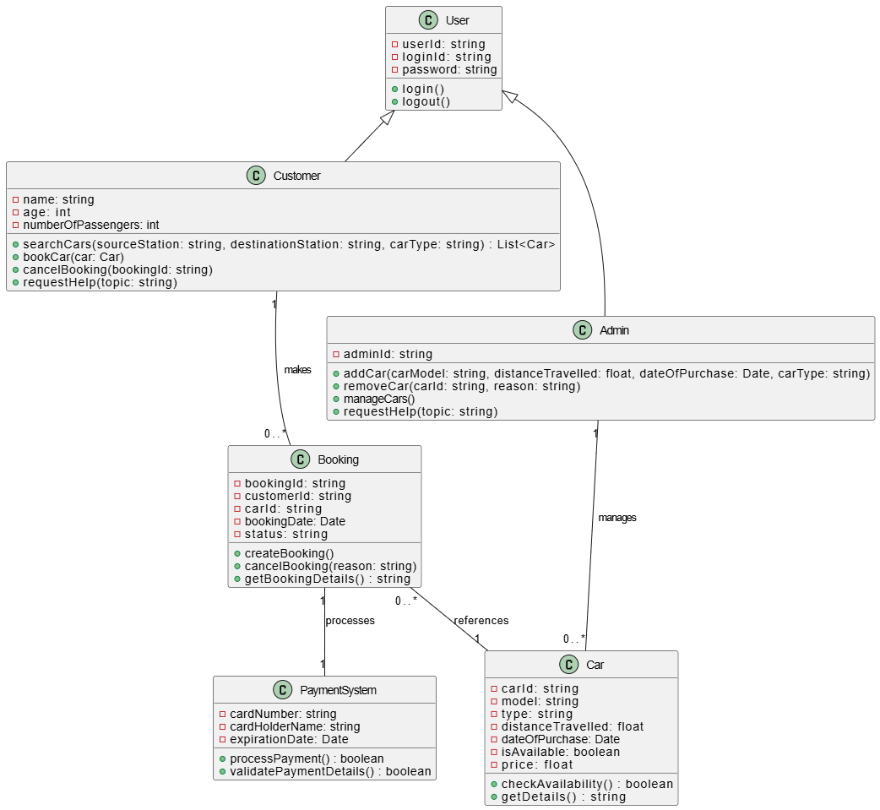
Class Diagram (GPT)

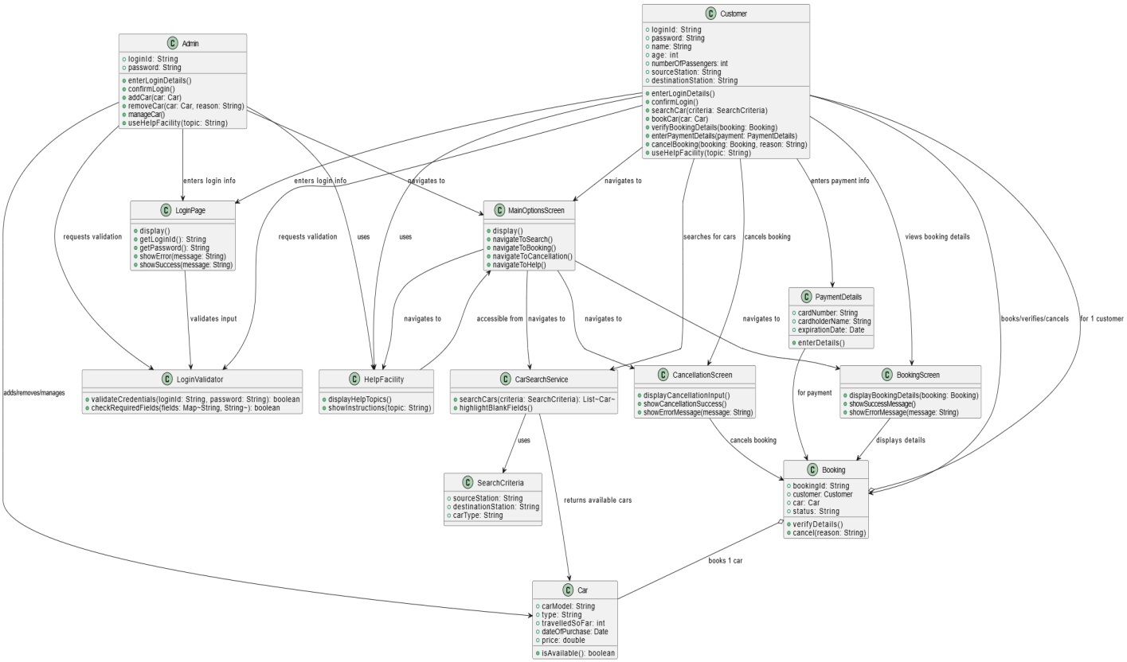

Sequence Diagram (VeriGen)
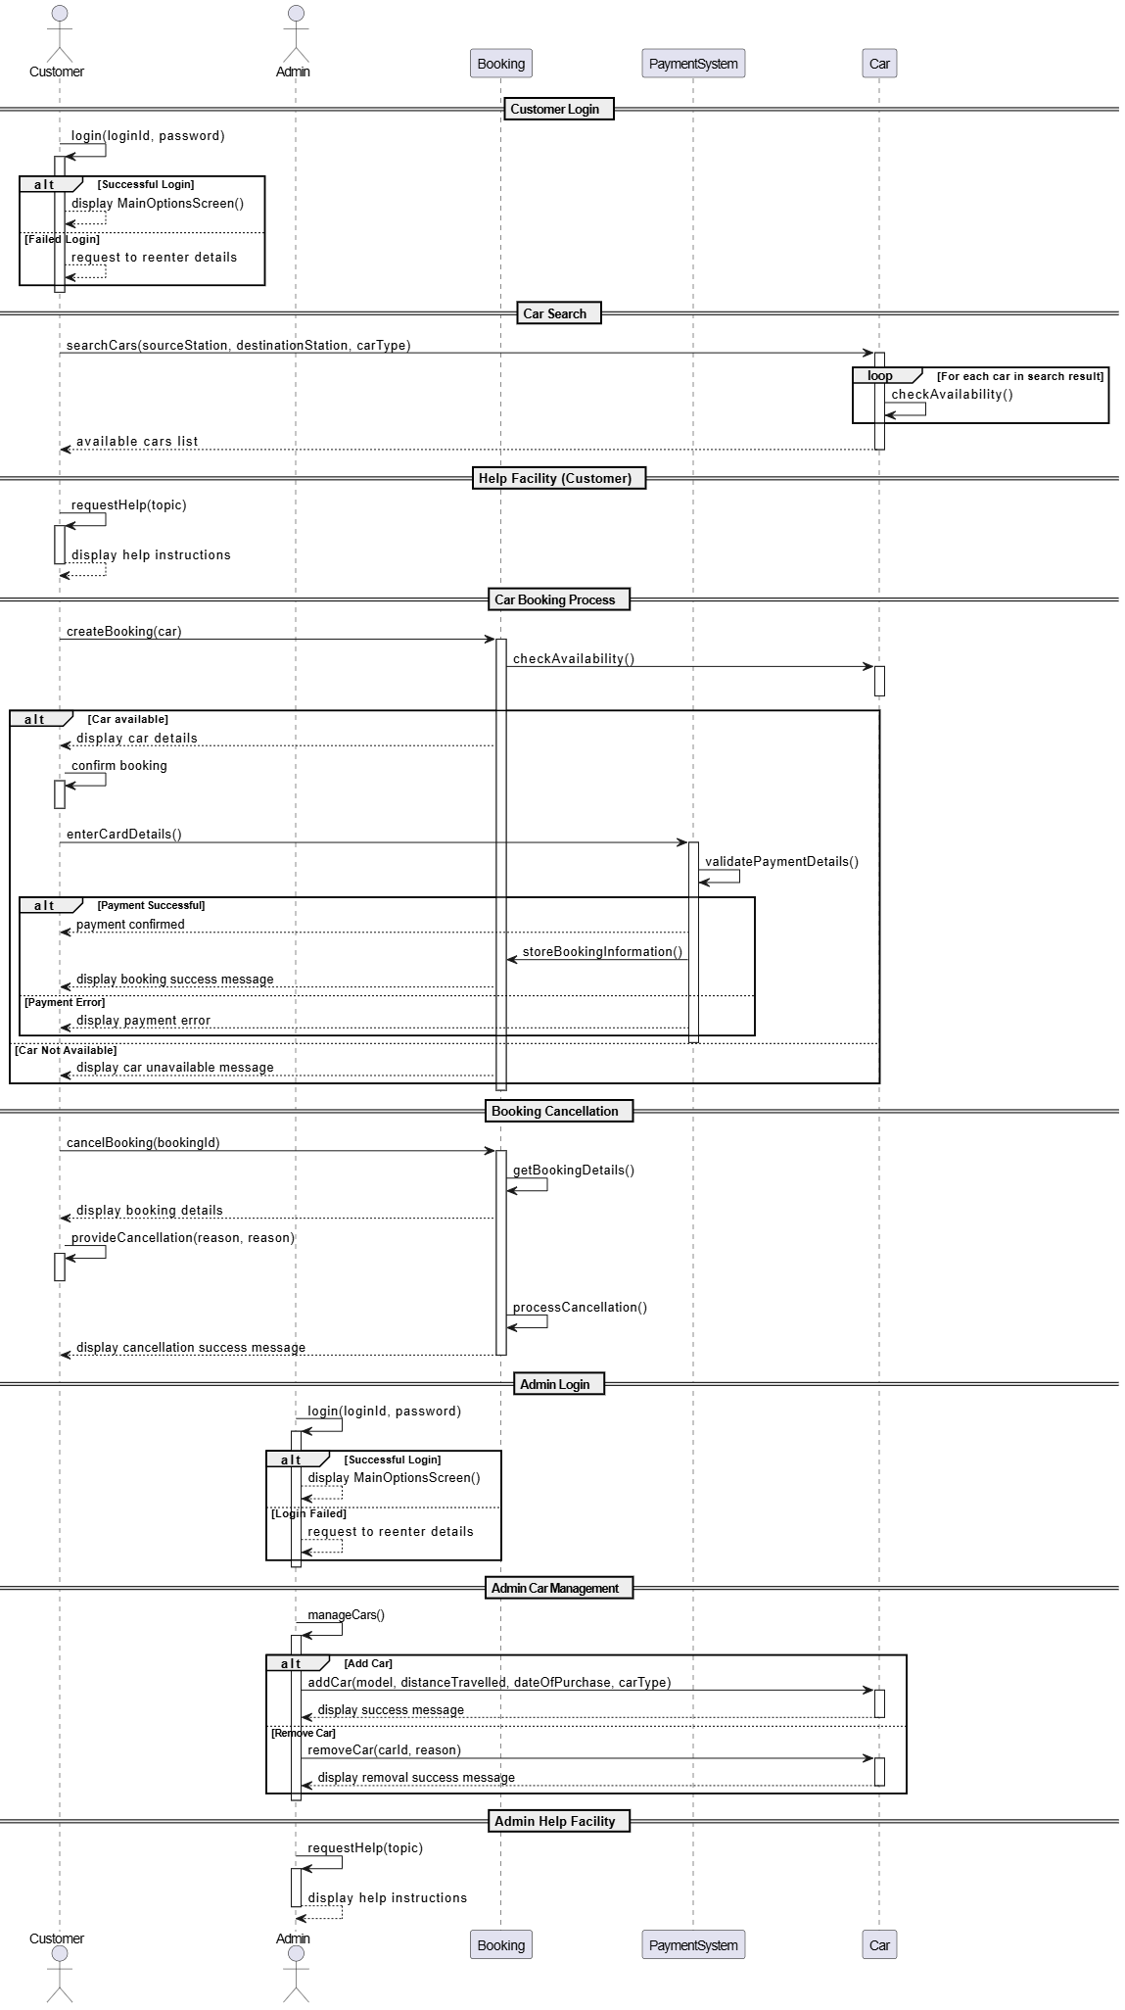
Sequence Diagram (GPT)
